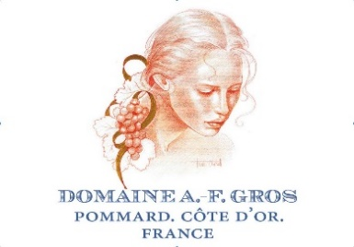

Dom A F Gros, Grand Cru 2013 Richebourg
Score 17/20
Rather dark and closed, and on the palate, this is big, powerful, but not especially beautiful. The layering and finesse you’d expect from a senior grand cru are not apparent at this stage. It’s good wine, for sure, but not magical, and hence not much of a step up from the village wines despite its greater mass. (AH)
Drink 2020-2028

Dom A F Gros, Les Pézerolles Premier Cru 2013 Pommard
Score 16.5/20
Muted, a bit green and grumpy on the nose, but there’s excellent vigour on the palate. Complex and spicy, with very well-rounded tannin, though a bit vanilla-sweet at the end. (AH)
Drink 2018-2024
Dom A F Gros, Aux Réas 2013 Vosne-Romanée
Score 17/20
A touch more floral than the Maizières, as well as a more assertive structure. Equal quality, different expressions – this one potentially longer lived. (AH)
Drink 2018-2025

Dom A F Gros, Aux Maizières 2013 Vosne-Romanée
Score 17/20
Quite a heady nose, with kirsch, spice and black cherry. Cool and composed on the palate, by contrast, with a lovely creaminess to the texture, and very gentle tannin. (AH)
Drink 2018-2023

Dom A F Gros, Clos de la Fontaine 2013 Vosne-Romanée
Score 16.5/20
Very delicate, pale, floral-strawberry-scented Vosne. It’s a little woody at this stage, perhaps, but there is real class and finesse here nonetheless. (AH)
Drink 2017-2022

Dom A F Gros 2013 Chambolle-Musigny
Score 17.5/20
Tender, blueberry- and jasmine-scented – very Chambolle. Lovely focus and delicacy on the palate: a really typical, eloquent expression of the village. (AH)
Drink 2017-2023

