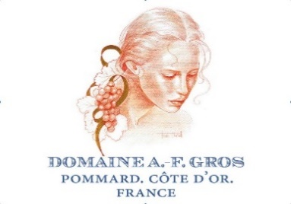
Dom A F Gros Pinot Noir 2016 Bourgogne
Score 16.5/20
Ambitious nose with loads of smoky oak influence and very ripe fruit. Has thoughts way above its station, but what's wrong with that when the flavours are so delicious? Finishes with a savoury granitic smokiness. (RH)
Drink 2018-2024

Dom A F Gros 2016 Hautes-Côtes de Nuits
Score 15/20
Sulphur free. While the nose and palate have fresh fruit at first, there is the tell-tale hamster-cage scent on the finish betraying the lack of sulphur. Approach with caution. (RH)
Drink 2018-2020

Dom A F Gros 2016 Chambolle-Musigny
Score 17/20
Edgy, tense nose – a rare chance to snap up a Chambolle 2016? Very lively and flirtatious. Good Value
Drink 2020-2028

Dom A F Gros, Clos de la Fontaine 2016 Vosne-Romanée
Score 16.5/20
Wonderfully pure, fruity nose. Very perfumed. Sweet fruit jumps out of the glass. Probably for relatively early pleasure. Not the most concentrated.
Drink 2021-2030

Dom A F Gros, Les Chalandins 2016 Vosne-Romanée
Score 17/20
Wonderful violet and rosehip scent, superbly crafted redcurrant and cranberry fruit, all wrapped up in oaky spice. Ripe and fruit-forward on the finish, and the structure is very accessible now. (RH) Drink 2018-2028

Dom A F Gros, Aux Réas 2016 Vosne-Romanée
Score 17/20
More smoky and savoury than their Chalandins, with a long, bonfire-smoke finish and succulent red fruits. The tannins are soft-edged but give enough shape to age well. (RH)
Drink 2020-2030

Dom A F Gros, Les Pézerolles Premier Cru 2016 Pommard
Score 17.5+/20
Combines wonderfully aromatic oak spices with flinty mineral aromas and oodles of black cherry fruit – very impressive. Powerful and rewarding on the palate, packing loads of flavour concentration into every mouthful. Bold and modern and shows just how luscious burgundy can be. (RH)
Drink 2021-2036

Dom A F Gros, Grand Cru 2016 Échezeaux
Score 16.5+/20
Bright, pale crimson. Quite an earthy nose. Round, juicy fruit. Not immediately obvious that this is grand cru level. For value I'd choose the Chambolle village wine any day.
Drink 2023-2031

Dom A F Gros, Grand Cru 2016 Richebourg
Score 17.5/20
Blackberries and black cherries, and plenty of substance to give shape on the palate, but it doesn't have the opulence of their Pézerolles Pommard. Hard to justify the premium on price that is bound to come with the grand cru label! (RH) Drink 2022-2042

