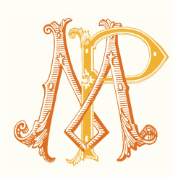
Mathias PARENT
WINE LIST
Prices are in Euros €, HT, Ex-cellar Beaune
Valid until 31/12/2014

Red Wines | 2012 | 2011 | 2010 | 2009 | 2008 | 2007 | 2006
Bourgogne |  | 11
Morey Saint Denis | 28 | 28 |  |  | 28
Chambolle Musigny | 30 | 30 |  |  | 30
Vosne Romanée | 30 | 30 |  | 30 | 30
Volnay 1er cru Les Fremiets | 35 | 35 | 35 |  | 35
Pommard 1er cru "Les Arvelets" | 39 | 39 | 39 | 39 | 39 | 39
Pommard 1er cru "Les Epenots" |  | 62 | 62 | 62 | 62
Pommard 1er cru "Les Rugiens" |  |  |  |  |  |  | 52
Clos Vougeot grand cru ** | 90 | 90 | 90
White wines
Chassagne Montrachet 1er cru Morgeot | 52 | 52
Corton Blanc Grand cru ** | 85 | 85

Conditionning is possible in case of 6 or 12 bottles of 0,75L
Wood cases of 6 bottles are proposed on demand at a unit price of 10 € HT.
** Grands crus are not sold alone but assorted with a mix of other appellations for the same financial amount.
Administrative fees will be charged for any special demands like certificate of origin, Certificate of analyses, or UPS/ DHL mails.
Payment: 60 days after shipment if your company is accepted by our credit insurance company, otherwise a payment before shipment is required.

