Burgundy 2013 - : Beaune and Its Environs
Summary: This section includes the oft-under valued appellation of Beaune, plus the village crus immediate north: Savigny-lès-Beaune, Pernand-Vergelesses, Aloxe-Corton, Corton, Chorey-lès-Beaune and Ladoix. This can get a little complicated. For example, Domaine A.F. Gros are here because they winery is based in Beaune and they own most of their vineyards, though you would have just as much right to include them in either Vosne or Pommard.
The vineyards that overlook Beaune are some of the most under-rated in the Côte d'Or and can represent some of its best values. That said, it has been in the "line of fire" in recent vintages and suffered more that its share of hail damage that has more or less wiped out prestigious vineyards such as Clos des Mouches in a matter of minutes. But it would be unwise to write it off completely and there are still great wines to be found. Savigny-lès-Beaune was also hit hard in 2013 and the wines seem compromised compared to 2012 for example. This resulted in some premier crus being blended together or into the village wine. Readers should note that several growers in these areas are due to be visited the very week after writing and I look forward to seeing how the likes of Tollot-Beaut and Michel Mallard fared.

Domaine A.F. Gros - The Beaune-Based Gros

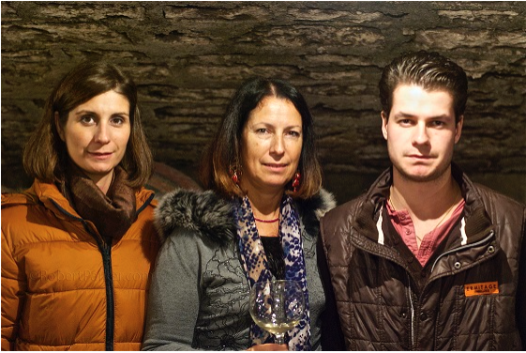
Pictured Caroline Parent, Anne-Françoise Gros and Mathias Parent

I often think that rather prospective MW students studying for years for those letters after their name, they should simply be asked to explain the various strands of the Gros family. If they can get that right, they deserve an MW as far as I am concerned. The domaine is managed by Caroline Parent who operates out of a winery just off the Beaune périphique. She took over from her father François and since 2010 has been joined by her 23-year old brother Mathias, who debuted his own wine under his name this year. They work together in the vineyard and look after the vinification, part of a long-term transfer from father to son. Caroline herself has her own négoçiant business with the wines sourced from her family's vines for the reds and bottled wines for the wines. Caroline also mentioned an intra-familial exchange in plots. Her Vosne-Romanée Clos de la Fontaine will go to Bernard Gros (Domaine Gros Frère & Soeur) in return for the Clos Vougeot Musigni, although there is no timeframe in place for that. I asked her about the growing season. "The spring was classic in March and April with a regular start of the growing season and a good amount of future grapes. In May and June we had continued rain and as a result a late flowering. The hail in Côte de Beaune on the 23rd of July impacted our vineyards in Savigny-lès-Beaune, Beaune, Pommard and for our parcels of Bourgogne located under Pommard. The average loss is about 80%. For Côte de Nuits we had some millerandage. Malic acidity was quite high. The grapes of Côte de Beaune and Côte de Nuits were all in a very good sanitary state at the time we harvested from 24 September: cool temperatures have prevented botrytis (we had only very few). Polyphenols have been extracted easily with a good color extraction as well, but the degrees were low. A the stage of the barreling, the wines are all in fruit, with a good acidity, and we are confident that for vintage 2013 if the quantity is lost, quality is not lost."
This domaine's wines tend to get a little over-shadowed or at least conflated with the various scions of the Gros family, in particular with her cousin, Anne. I find the wines far improved than a decade ago and their 2013s are worthy follow-ups to the 2012s, even if they do not quite reach the same level of quality. Some of the hail-affected vines in the Côte de Beaune seemed a little downtrodden by the challenges of the vintages, though there was some surprisingly fine examples from Savigny courtesy of their vines in les Boucherottes and Clos des Guettes. Within Vosne, I discerned as much joy in the Echézeaux as the Richebourg and given their prospective prices I would probably err towards the former.

