BOURGOGNE

DOMAINE A.F GROS & FRANCOIS PARENT
www.af-gros.com
www.parent-pommard.com

Siège Social & BUREAUX : LA GARELLE – 5 Grande rue –
F-21630 POMMARD
Tél. 33 03 80 22 61 85 Fax : 33 03 80 24 03 16
EMAIL af-gros@wanadoo.fr

THE STORY OF VINTAGE 2013

A reminder of the weather: “A well-watered vintage..!”

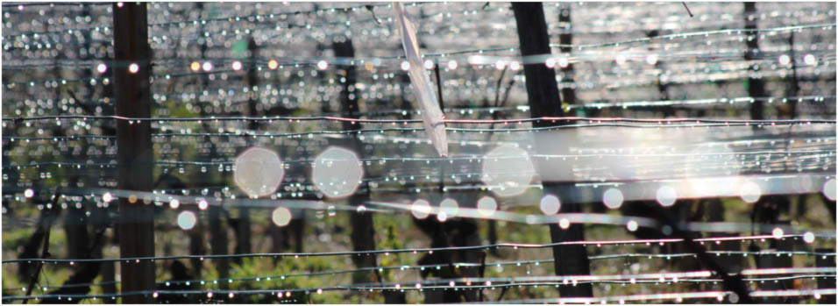

A rainy autumn, then a damp winter and a spring adorned with ….raindrops like pearls.
Working in the vines was complicated in every respect and throughout the year.

Early green growth was timid and slow and rain during vine flowering provoked a high level of flower-shatter (the consequence of which was a significant loss of part of the crop and extremely variably-sized grape bunches)
In spring, the small new leaves were yellow (and not deep green) through lack of warmth during their development.

Temperatures finally increased at the end of June with -at last- Sunshine and Heat.
But the dampness remaining in the soil created heavy, muggy weather and storms broke over the vineyards with devastating violence and hailstones on 23rd July – mainly in the Côte de Beaune between Volnay, Pommard, Beaune and Savigny les Beaune, where the vines lost 50% of their fruit.

It should be noted that in the last two vintages, hailstorms have struck the same geographical areas…. and the same appellations!

Good weather only really became stabilized at the end of July, while August saw the temperatures rise to 30°C for several weeks (which healed vines damaged by hail and encouraged vegetative growth). The nights remained cool. September was mixed, with cool weather still alternating with rain under heavy skies and a lack of luminosity which was finally to be the main characteristic of the year 2013.

The grape harvest and the vintage:

On La Côte, grape harvesting began on 4th October, therefore 100 days after flowering (and it is necessary to go back to the 1980s to find harvests so late – knowing that we always count between 90 and 100 days after vine flowering to determine the date of the harvest).

We then followed on straight away with the harvest in the Hautes Côtes, on 10th October, without waiting and with the same team of harvesters, fearing problems of rot as the rain had returned to such an extent that, taking into account the lateness of the season, further ripening was not envisaged in a positive light.

The crop had to be saved by picking quickly with a large team.

As always:
- Harvesting by hand exclusively, and in all our parcels of vines.
- 5 levels of grape sorting so that only perfect bunches arrive at the vat.
- A vinification adapted to the vintage to extract its essential substance, different every year, and to underline the authenticity of terroir through each appellation.

THE STYLE OF THE VINTAGE

The red wines were vinified and aged so as to benefit from the main advantage of the vintage: Fruit (and the Pinot Noir variety can wonderfully express the variation of scents from red and black fruits in young wines).
The palate is fleshy with good substance (thanks to the small yields), with silky nuances and rich fruitiness.
So much so that the wines are revealed as full of charm, and we advise that they be drunk over a period of 3 to 5 years: almost en primeur (even if the grands crus can age a little longer).

