BOURGOGNE

DOMAINE A.F GROS & FRANCOIS PARENT
www.af-gros.com
www.parent-pommard.com

Siège Social & BUREAUX : LA GARELLE – 5 Grande rue –
F-21630 POMMARD
Tél. 33 03 80 22 61 85 Fax : 33 03 80 24 03 16
EMAIL af-gros@wanadoo.fr

THE STORY OF VINTAGE 2014

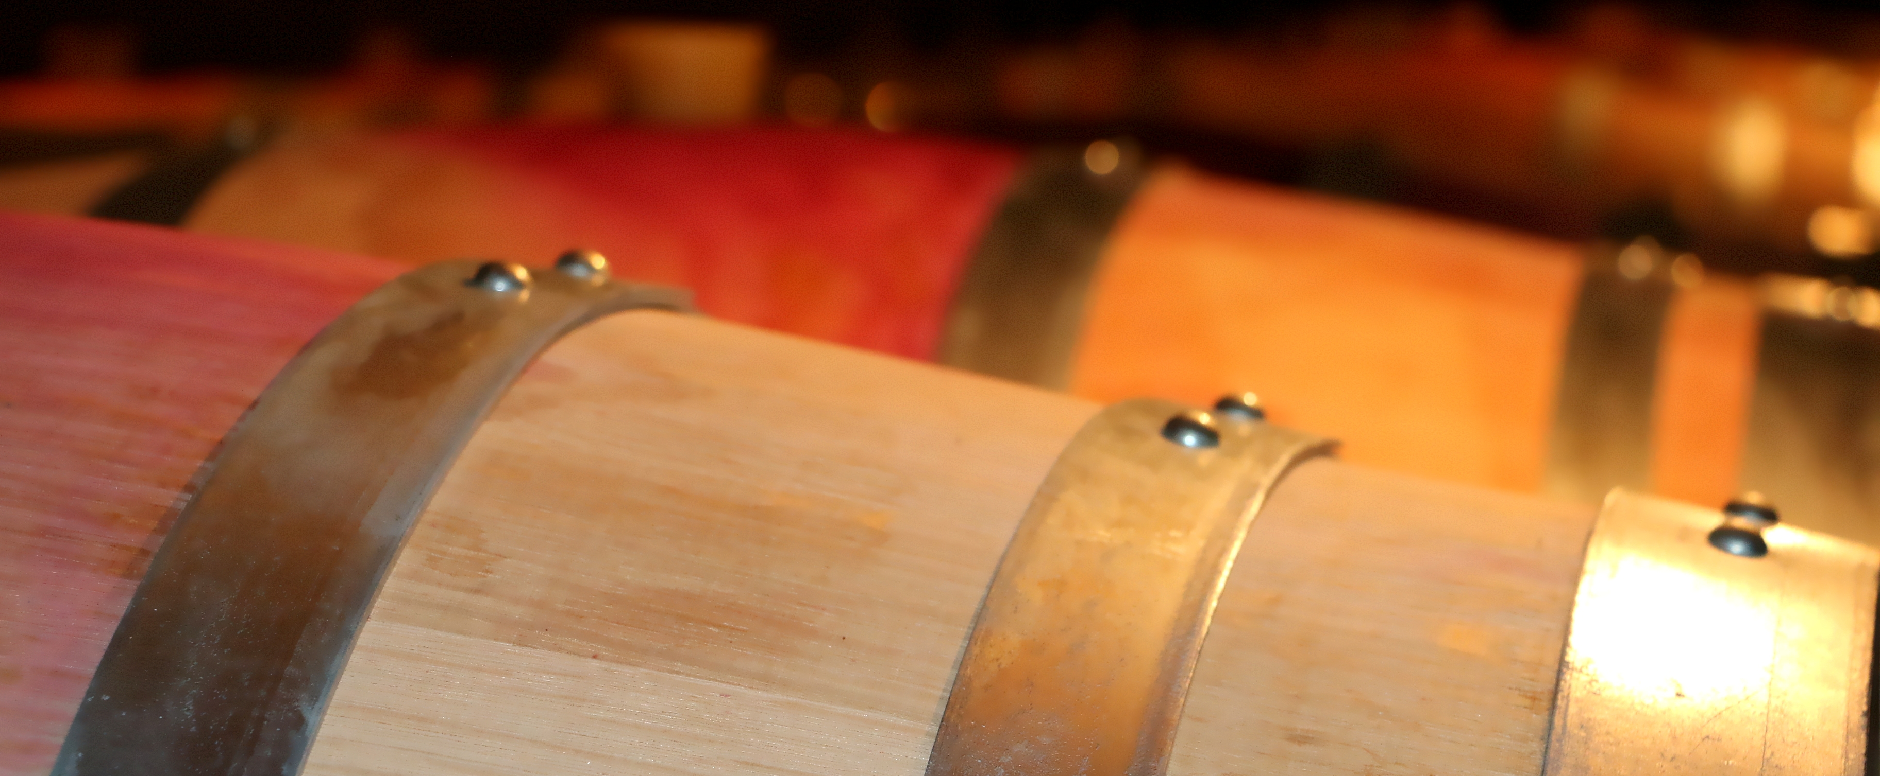

After an early and warm spring, we had a great number of clusters. Sadly we had a big hailstorm on the 28th of June (the 3rd year in a row) over the vineyards of Beaune, Pommard and Volnay and we lost a big part of the harvest that day.

July was sunny and dry, and the vines touched by the hail healed well.
After quite wet and cloudy August, September was sunny and warm again and the ripeness was good enough to start the harvest on the 13th of Sept.

At the sorting out table, we had to reject some unripe grapes and some affected by Drosophila suzukii “vinegar flies” in some vines in Vosne Romanée.
Yields are low because of millerandage and because of the hailstorm for the appellations in Cote de Beaune.

The new vintage shows a perfect balance maturity/acidity, with thick skins and great colors. Therefore, we are extremely happy with the quality of vintage 2014 which is a classic Burgundy vintage, good for ageing.

