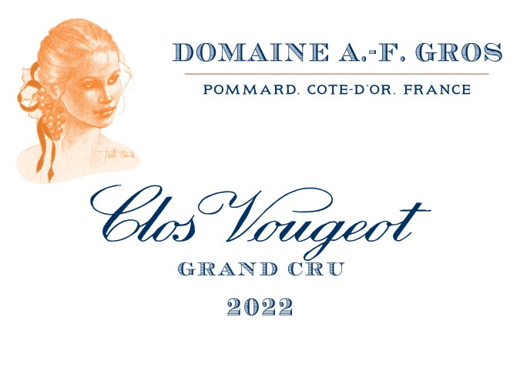

Domaine A.F Gros Clos Vougeot Grand Cru

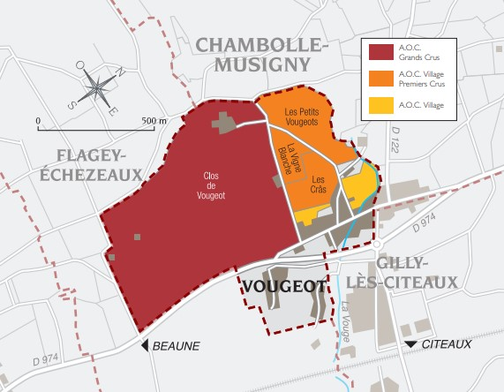

100% Pinot Noir
A une altitude étagée de 240 à 280m, sols bruns calcaires d’une faible profondeur.
Cette parcelle de xx Ha a récemment rejoint le Domaine etc
Traditional vineyard management based on sustainability principles.
We engage in selective pruning, along with optimized leaf pulling, green harvest when needed, and ploughing of the soils.
The grapes, once cut, are brought back to the winery in less than 20 minutes.
100% manual harvesting. 30% of whole bunch.

Winemaking
For the winemaking process, we use stainless steel tanks and oak barrels.
Cold maceration (5°C) is done for about 3-5 days to extract flavor and color. During that time, we do some remontage (pump over) to keep a good contact between solid and liquid parts. After 5 days, the tanks are heated up to 25-30°C for over 10 days.
The wood for the oak barrels comes primarily from forests of Châtillonais and Fontainebleau. This wine is aged for an average of 18 months (100% new oak).

Tasting notes
A King among Kings: opulent, rich, concentrated, generous, offering exceptional cellaring !
With a color evolving from raspberry red to the deepest garnet over time, Clos Vougeot wine develops all its aromatic complexity: aromas of flowers (rose, violet), small red fruits (blackberry, wild mint, licorice, truffle) and offers a long persistence in the mouth. Noblesse obliges, a Clos Vougeot will be honored with musky, marbled meats: braised lamb, feathered game, a beautiful steak seared in the hearth. Epoisses and Cîteaux cheeses will also be part of the celebration on your table!

