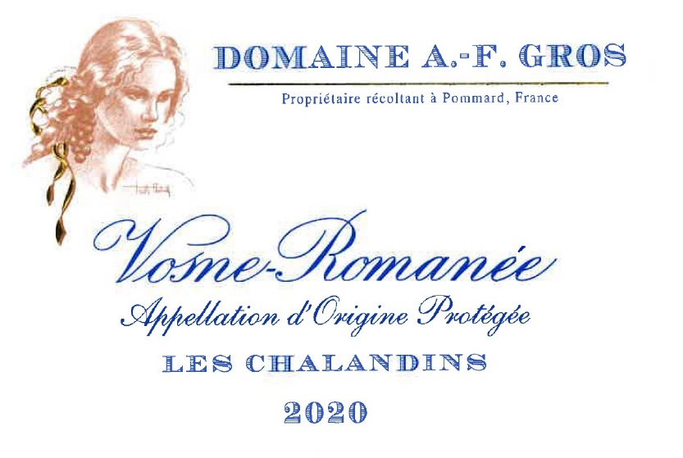
Domaine A.F Gros Vosne Romanée les Chalandins

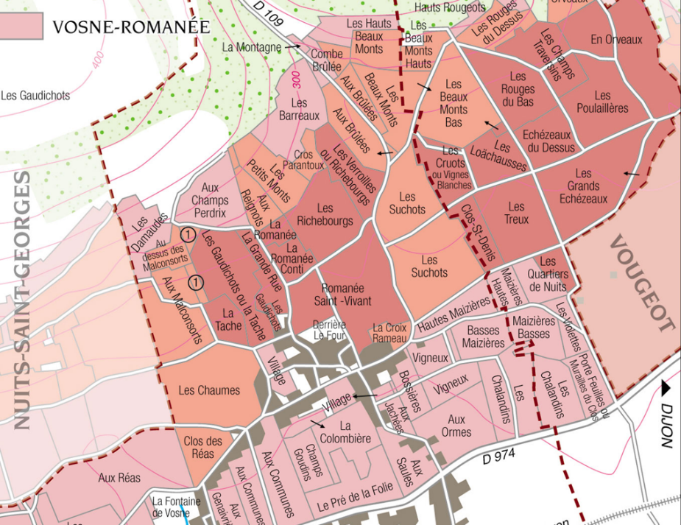
100% Pinot Noir
Our vineyard is located in the neighborhood of Clos Vougeot

The soils are limestone mixed with clayey marls. Depth of soil varies from some tens of centimeters to 1 meter deep. The exposure is easterly.
Traditional vineyard management based on sustainability principles.
We engage in selective pruning, along with optimized leaf pulling, green harvest when needed, and ploughing of the soils.
The grapes, once cut, are brought back to the winery within 20 minutes to ensure freshness.
100% manual harvesting.

Winemaking
For the winemaking process, we use stainless steel tanks and oak barrels.
Cold maceration (5°C) is done for about 3-5 days to extract flavor and color. During that time, we do some remontage (pump over) to keep a good contact between solid and liquid parts. After 5 days, the tanks are heated up to 25-30°C for over 10 days.
The wood for the oak barrels comes primarily from forests of Châtillonais and Fontainebleau. This wine is aged for an average of 18 months (50% new barrels).

Tasting notes
Pure ruby color, with ripe fruit and spices in the bouquet, in addition to the red fruit aromas, These refined and well-blended aromas evolve with age into cherries-in-brandy, preserved fruits, leather and fur, and gamey/woodland scents. On the palate the wine is velvety and distinguished - the Pinot Noir at the top of its form. The wine may seem a little austere in its youth; it needs time in the bottle to develop structure and fleshy texture.

