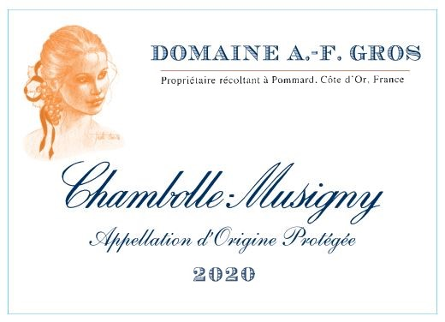
Domaine A.F Gros Chambolle Musigny

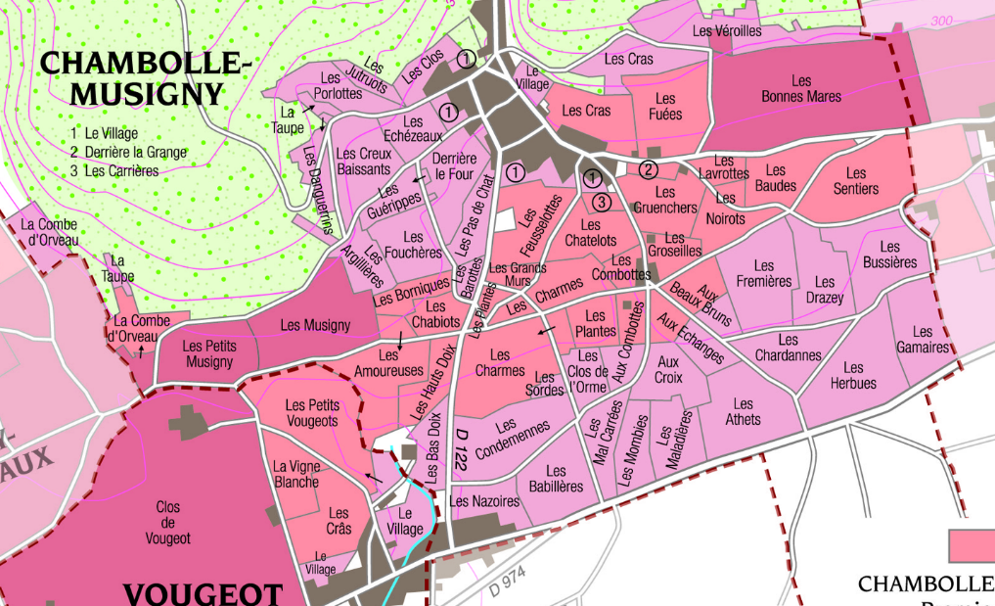
100% Pinot Noir
Our 0.39 ha vineyard is split between various parcels in the Southern part of the appellation.
Shallow soils, with gravel and limestone rocks that allow for aeration and deep root penetration.
Traditional vineyard management based on sustainability principles.
We engage in selective pruning, along with optimized leaf pulling, green harvest when needed, and ploughing of the soils.
The grapes, once cut, are brought back to the winery in less than 20 minutes.
100% manual harvesting.

Winemaking
For the winemaking process, we use stainless steel tanks and oak barrels.
Cold maceration (5°C) is done for about 3-5 days to extract flavor and color. During that time, we do some remontage (pump over) to keep a good contact between solid and liquid parts. After 5 days, the tanks are heated up to 25-30°C for over 10 days.
The wood for the oak barrels comes primarily from forests of Châtillonais and Fontainebleau. This wine is aged for an average of 18 months (50% new oak).

Tasting notes

Chambolle-Musigny has a distinct personality and features. Intense bouquet composed of violet and small red fruits (raspberry, strawberry). Rich, fragrant and complex, it lines the palate with silk and lace. Its delicate and fleshy texture is paired with a solid and durable structure. Fabulous with game and cheeses like Brillât Savarin, Citeaux or Reblochon.

