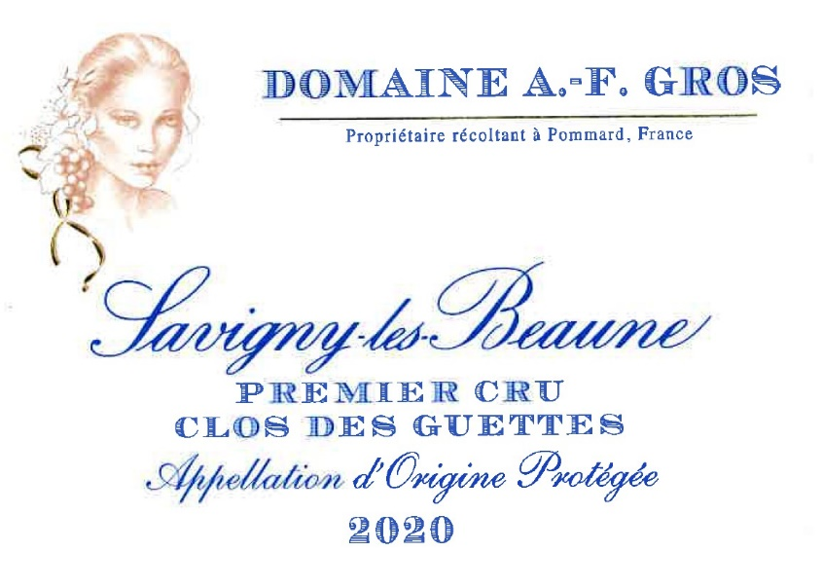
Domaine A.F Gros Savigny les Beaune 1er Cru Clos des Guettes

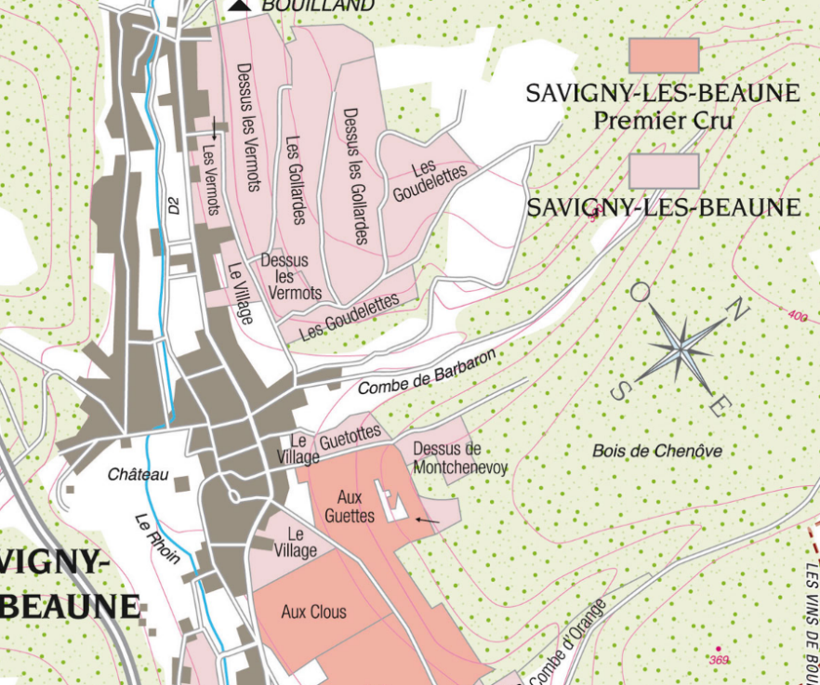
Winemaking
For the winemaking process, we use stainless steel tanks and oak barrels.
Cold maceration (5°C) is done for about 3-5 days to extract flavor and color. During that time, we do some remontage (pump over) to keep a good contact between solid and liquid parts. After 5 days, the tanks are heated up to 25-30°C for over 10 days.
The wood for the oak barrels comes primarily from forests of Chatillonais and Fontainebleau. This wine is aged for an average of 18 months (65% new barrels).

100% Pinot Noir
Our 0.67 ha vineyard is located in the walled vineyard called “Aux Guettes”; the name comes from an ancient watchtower that oversees the vineyard.
Gentle gradient, with an altitude of 300 meters at first but stiffer as one goes higher. The geology is that of the hill of Corton. Southerly exposure, with gravelly, clay-limestone soils.
Traditional vineyard management based on sustainability principles.
We engage in selective pruning, along with optimized leaf pulling, green harvest when needed, and ploughing of the soils.
The grapes, once cut, are brought back to the winery within 20 minutes to ensure freshness.
100% manual harvesting.

Tasting notes
Coming from very small berries, the wine has a deep cherry color, a bouquet of small red and black fruits (blackcurrant, cherry, raspberry) and flowers (violet). Ample and discreetly tannic body. Roundness, volume, power and balance are all here, and in just the right proportions.

