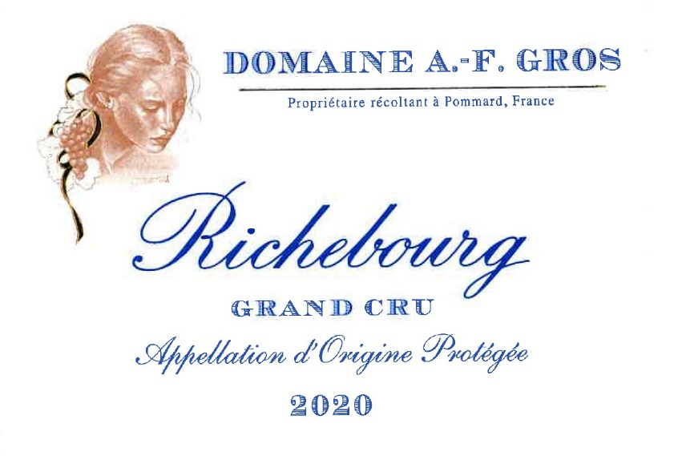
Domaine A.F Gros Richebourg

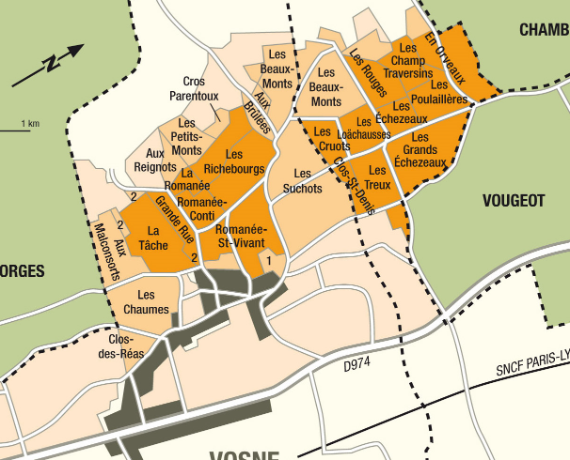

Tasting notes
Deep dark color, with hints of ruby. Bouquet of red fruit, superb mouth-fill. It has a clearly defined structure, full-bodied rather than flowery and at times a little wild.
It will stand aging for as long as 30-50 years. Round, elegant, its mature aromas evoke violet, humus and underbrush. Glorious ambassador of Burgundy’s royal reputation.
Winemaking
For the winemaking process, we use stainless steel tanks and oak barrels.
Cold maceration (5°C) is done for about 3-5 days to extract flavor and color. During that time, we do some remontage (pump over) to keep a good contact between solid and liquid parts. After 5 days, the tanks are heated up to 25-30°C for over 10 days.
The wood for the oak barrels comes primarily from forests of Chatillonais and Fontainebleau. This wine is aged for an average of 18 months (100% new barrels).

100% Pinot Noir
Our vineyard is located in the heart of the best appellations of Burgundy.
Vines are 15, 25 and 75 years old.
The sub-soil consists of limestone and white marl under clay-flint soils up to 40 cm in depth on a gently sloping site. The soil is quite light and gravelly, brown or reddish in color. It dates back to the Jurassic period, some 150 million years ago.
Traditional vineyard management based on sustainability principles.
We engage in selective pruning, along with optimized leaf pulling, green harvest when needed, and ploughing of the soils.
The grapes, once cut, are brought back to the winery within 20 minutes to ensure freshness.
100% manual harvesting.

