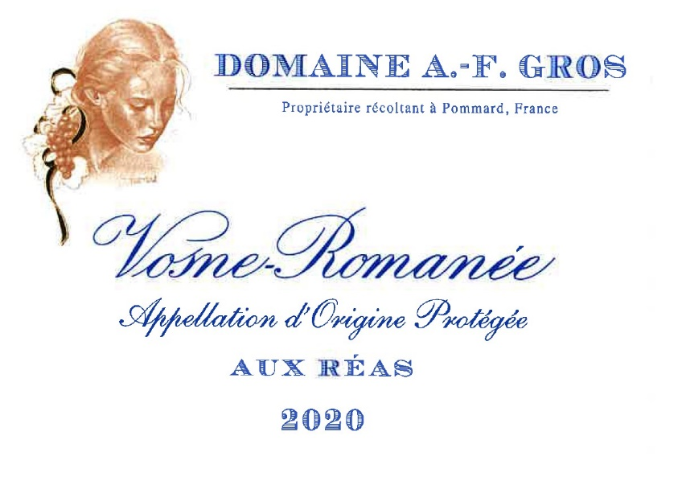
Domaine A.F GROS Vosne Romanée aux Réas

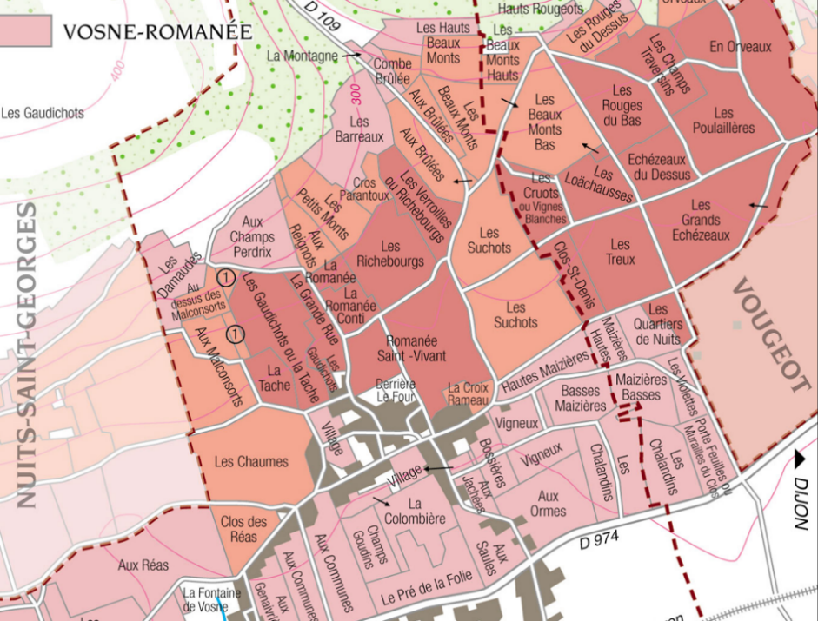
100% Pinot Noir
Our vineyard is located next to Clos des Reas.

The soils are limestones, fine-textured marls, and clays.

Traditional vineyard management based on sustainability principles.
We engage in selective pruning, along with optimized leaf pulling, green harvest when needed, and ploughing of the soils.

The grapes, once cut, are brought back to the winery very rapidly in temperature-controlled trucks.
100% manual harvesting.

Winemaking
For the winemaking process, we use stainless steel tanks and oak barrels.
Cold maceration (5°C) is done for about 3-5 days to extract flavor and color. During that time, we do some remontage (pump over) to keep a good contact between solid and liquid parts. After 5 days, the tanks are heated up to 25-30°C for over 10 days.
The wood for the oak barrels comes primarily from forests of Chatillonais and Fontainebleau. This wine is aged for an average of 18 months (50% new barrels).

Tasting notes
Deep color between crimson and purple, dark and luminous. It develops aromas of violet and small fruits (Morello cherry, blackcurrant). When older, it leans towards underbrush, fallen leaves and truffle over animal notes. In the mouth, it has a rich structure, while its tannins are nonetheless delicate.
Acidity and chewiness are harmoniously balanced, with licorice in the finish.

