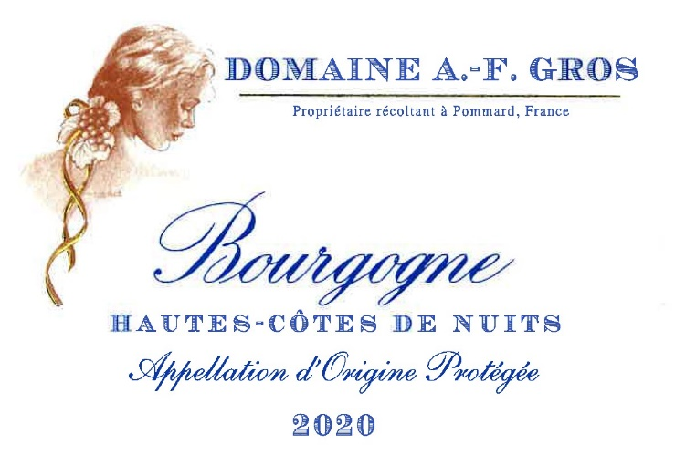
Domaine A.F Gros Bourgogne Hautes Cotes de Nuits Rouge

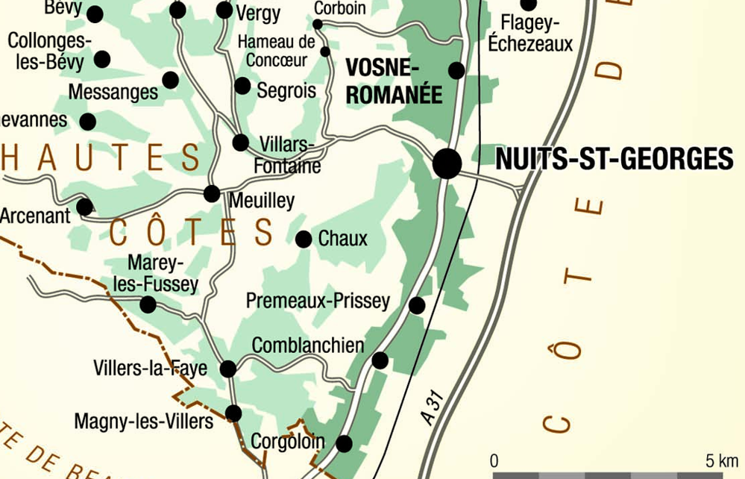
Tasting notes

Cherry red in color, with hints of ruby. The nose releases notes of cherry, blackcurrant raspberry, wild strawberry. In the mouth, the attack is smooth and forthright, with chewy tannins. Perfect with grilled red meat, or a chicken recipe with mushrooms.
The finish is rich, with hints of licorice, sometimes evolving to spicy aromas.

Winemaking
For the winemaking process, we use stainless steel tanks and oak barrels.
Cold maceration (5°C) is done for about 3-5 days to extract flavor and color. During that time, we do some remontage (pump over) to keep a good contact between solid and liquid parts. After 5 days, the tanks are heated up to 25-30°C for over 10 days.
The wood for the oak barrels come primarily from forests of Chatillonais and Fontainebleau. Two thirds of this wine is aged in wood for an average of 12 months (10% new oak).

100% Pinot Noir
Our 2.23 ha vineyard is located in the commune of Arcenant. High vines (6’), low density, at an altitude of 400 meters.
Limestone and marls from the Jurassic period.
We use traditional vineyard management based on sustainability principles.
We engage in selective pruning, along with optimized leaf pulling, green harvest when needed, and ploughing of the soils.
Because of the altitude, the harvest starts an average 2 weeks after the rest of the estate.
The grapes, once cut, are brought back to the winery in less than 20 minutes.
100% manual harvesting.

