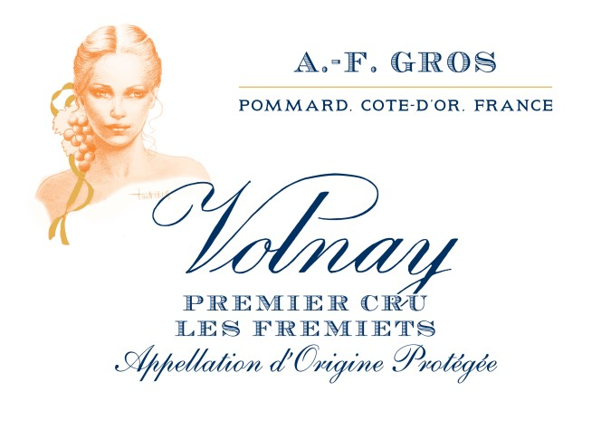
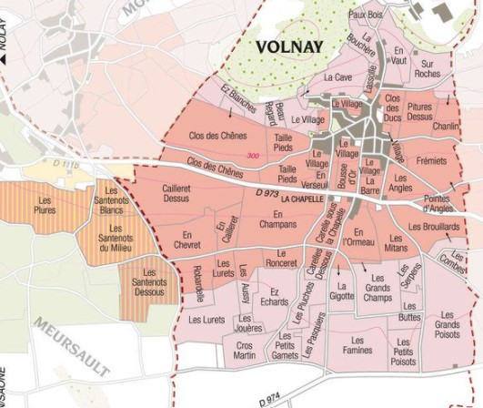
,

100% Pinot Noir

The soils on the northern part close to Pommard contains alluvial cones brought by the “Combe de Pommard”, and deep clay-limestone substrate which brings more elegance to the wines.
Traditional vineyard management based on sustainability principles.

We engage in selective pruning, along with optimized leaf pulling, green harvest when needed, and ploughing of the soils.
The grapes, once cut, are brought back to the winery in less than 20 minutes.

100% manual harvesting.

Tasting notes

Volnay 1er cru les Fremiets is one of the most delicate and subtle wine of this appellation.
It has an intense bouquet composed of small red fruits (raspberry, strawberry) and spicy notes. Rich, and deep, it is complex and intense on the palate. Fabulous with game and cheeses.

AF Gros Volnay 1er cru les Fremiets
Winemaking
For the winemaking process, we use stainless steel tanks and oak barrels.
Cold maceration (5°C) is done for about 3-5 days to extract flavor and color. During that time, we do some remontage (pump over) to keep a good contact between solid and liquid parts. After 5 days, the tanks are heated up to 25-30°C for over 10 days.
The wood for the oak barrels comes primarily from forests of Chatillonais and Fontainebleau. This wine is aged for an average of 18 months (65% new oak).

